Basic abstract UML Diagram for the WordDrag Application

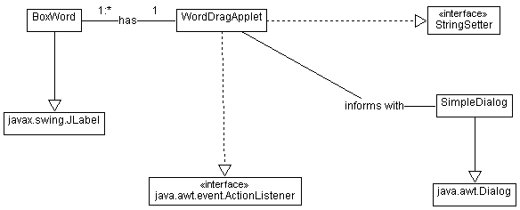

Detailed class UML of the WordDrag Application



